**Brainstorm & Idea Prioritization**

|  |  |
| --- | --- |
| 📅 Date | 31 January 2025 |
| 👥 Team ID | LTVIP2025TMID31117 |
| 👥 Team Size | 4 |
| 👑 Team Leader | Sai Vinay Biruda |
| 👤 Team Members | - Pilli J V Durga Prasanna Kumar  - Pradeep Kumar  - Pattucharla Lakshmi Anjana Sridevi |
| 📌 Project Name | Workforce Administration Solution (Dev) |

### Step 1: Team Gathering, Collaboration, and Select the Problem Statement

The team conducted collaborative sessions involving Salesforce admins, HR stakeholders, and project managers to analyze existing challenges in workforce and asset management. After discussions, the selected problem statement was:

“Our organization struggles with manual tracking of employee project assignments and asset allocations, leading to inefficiencies, data inconsistencies, lack of real-time visibility, and potential asset misplacement. There is a need for a centralized, automated solution on Salesforce to streamline and enhance workforce administration.”

### Step 2: Brainstorm, Idea Listing, and Grouping

💡 **Idea Listing** - Create custom Salesforce objects (Employee, Project, Asset) - Set up many-to-many relationship: Employee ↔ Project  
- Set up one-to-many (or configurable) relationship: Employee ↔ Asset  
- Use Salesforce Flows to automate assignments  
- Generate reports and dashboards for workload, project, and asset tracking  
- Send automated alerts for overdue assets  
- Apply role-based access control for HR, managers, and employees  
- Enable employee self-service access for viewing assignments  
- Plan future integration with external HR/ERP platforms (Workday, SAP)  
- Explore mobile app optimization for on-the-go access

**Idea Grouping**

| Category | Ideas |
| --- | --- |
| **Data Model** | Custom objects, relationships |
| **Automation** | Flows for assignments, alerts |
| **Reporting** | Dashboards, reports, compliance-ready data |
| **Access Control** | Role-based permissions, self-service |
| **Enhancements** | Future integration (HR systems), mobile app |

📈 Data Model ER Diagram

Below is a visual representation of the custom data model design that supports our prioritized ideas.

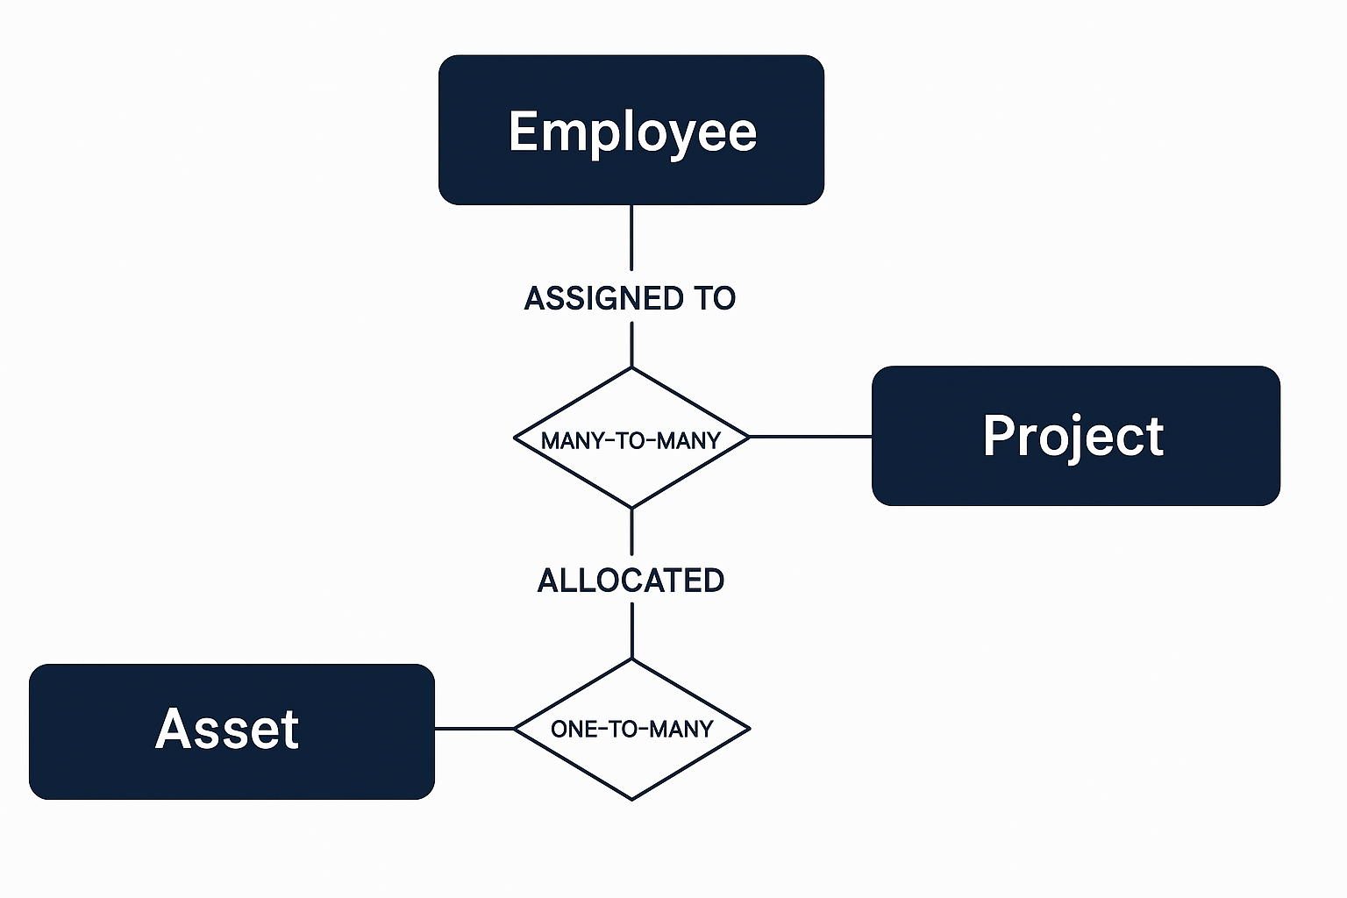

### Step 3: Idea Prioritization

| Idea / Feature | Priority |
| --- | --- |
| Custom Salesforce data model (Employee, Project, Asset) | High |
| Automation of project and asset assignments | High |
| Dashboards and reports for workforce monitoring | High |
| Role-based access and permissions | High |
| Overdue asset alerts | Medium |
| Self-service employee portal | Medium |
| External HR/ERP system integration (Workday, SAP) | Low (future scope) |
| Mobile app optimization | Low (future scope) |

Prioritization was based on immediate impact, feasibility within the initial phase, and alignment with organizational goals.